Object oriented programming Object Oriented Analysis and design

|  |  |  |  |
| --- | --- | --- | --- |
| Group Id: | | 28 | |
| Registration number: | 2020-CS-71 | | 2020-CS-84 |
| Name: | Esha Tur Razia | | Sana Shafique |
| Project name: | Recipe Management System | | |

# Explanation:

Recipe management system is used by **restaurant** owners to manage the **recipes** and **shopping lists**. While making recipes in the kitchen chefs need to manage **ingredients** and the **procedures** this work is done manually and requires a lot of effort so to reduce this difficulty in the modern era of computer we can use recipe management system. So the ingredients their **quantity** and procedures of **recipes list** can be evaluated digitally saving time and manual effort.

# Identifying concepts:

Shopping lists

Recipes

Restaurant

Quantity

Procedures

Recipe list

Ingredients

# Rough sketch of classes:

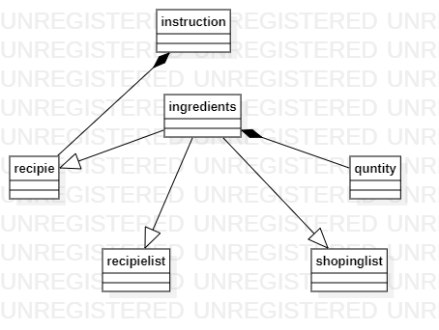

**Quantity**

# Sequence:

* The recipes along with their procedures will be stored in the system
* The Admin can add, edit, delete or view the recipes
* User can just view and search the recipes
* Data such as ingredients of the recipes will be managed

# UML Diagram:

